# ARMOR: RIDE WITH AUGMENTED SAFETY

***Project Reference No.:*** *48S_BE_0505*

College : Sambhram Institute Of Technology

Branch : Department of Computer Science and Engineering

Guide(s) : Prof. Jyothi S S.

[jyothistanik@gmail.com](mailto:jyothistanik@gmail.com)

9449705175

Student(s) : Darshan R

[darshanrajanna07@gmail.com](mailto:darshanrajanna07@gmail.com)

8618917040

Deeksha M

[deekshamanjunath24@gmail.com](mailto:deekshamanjunath24@gmail.com)

8147274560

M Kusuma

[varalm1981@gmail.com](mailto:varalm1981@gmail.com)

8660112123

Keywords:

Smart Helmet, ESP32, Speed Monitoring, OLED Display, Safety Technology, Road Safety, Automation.

Introduction:

In recent years, the integration of technology with personal safety gear has given rise to innovative smart wearables, with smart helmets leading the charge in enhancing road safety. The **Armor: Ride with Augmented Safety** is a next-generation, intelligent headgear designed to ensure rider safety, enable real-time monitoring, and offer interactive features powered by modern embedded systems.

This project introduces a helmet equipped with an **ESP32 microcontroller**, an **OLED display**, voice recognition capabilities, and Bluetooth communication. The helmet serves as more than just protective gear; it is a **multifunctional device** capable of displaying speed, accepting voice commands, and providing voice feedback through a built-in speaker system.

The primary goal of this smart helmet is to enhance rider awareness and safety by combining hardware and software in a compact, wearable form. By integrating these technologies, this project demonstrates how emerging systems can create a **low-cost, efficient, and scalable smart safety solution** for everyday commuters.

Figure 1: Overview of Smart Helmet

Objectives:

* To design a smart helmet that ensures rider safety through real-time speed monitoring.
* To implement voice recognition for hands-free interaction and control.
* To enable wireless communication between the helmet and a smartphone using Bluetooth.
* To integrate a compact display system for visual feedback directly on the helmet.
* To implement a **power-efficient** system design to ensure extended battery life while maintaining performance.
* To enhance the **user experience** by providing intuitive feedback and seamless interaction between the rider and the helmet's features.

Methodology:

**Hardware Components:**

* ESP32 – A powerful microcontroller with Wi-Fi and Bluetooth for IoT applications.
* INMP441 – A digital MEMS microphone for capturing high-quality audio.
* NEO6M – A GPS module for real-time location tracking and navigation.
* MAX98357A – A digital-to-analog audio amplifier for driving a small speaker.
* Small Speaker – Outputs voice assistance and notifications for the rider.
* Buzzer – Provides sound alerts for emergency and notifications.
* 2 Small LEDs – Indicate power status and emergency alerts.
* LM2596 DC-DC – A voltage regulator for stable power supply.
* MPU6050 – A motion sensor that detects acceleration and tilt for safety monitoring.
* 2x 3.7V Battery – Rechargeable lithium batteries to power the system.
* OLED Display: A compact, low-power screen used for showing real-time speed, notifications, and system status clearly even in daylight.
* Power Button: To turn the helmet on/off or switch modes.

**Software components:**

1. Google API – Provides real-time weather updates and chat assistant functionality.
2. Arduino IDE – Used for writing, compiling, and uploading code to the ESP32.
3. Basic C++ (Arduino Coding) – The programming language used to control hardware components and functionalities.

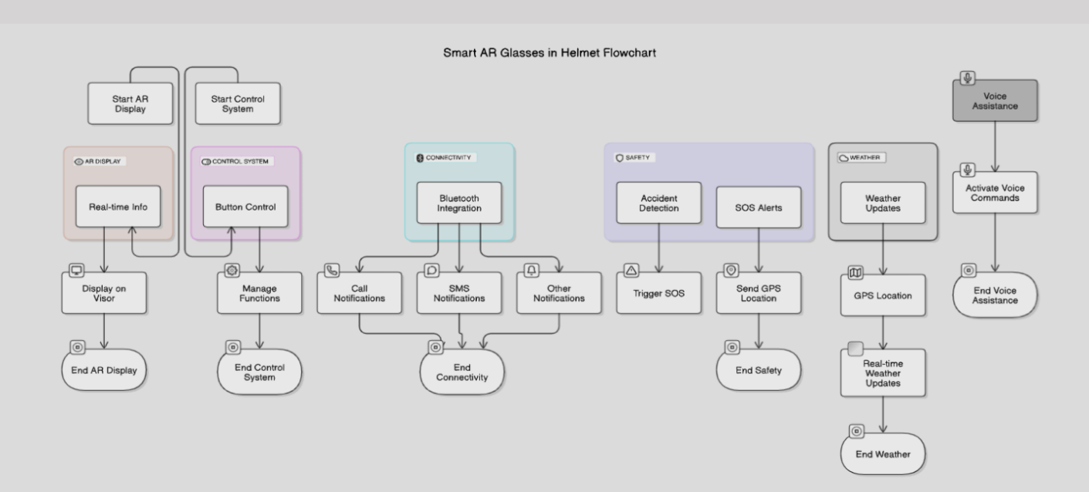

Figure 1: Flowchart

Result and ****Conclusion****:

In conclusion, the **Armor: Ride with Augmented Safety** successfully integrated advanced technologies to enhance rider safety. The core features, including **real-time speed monitoring**, **voice commands**, and **audio feedback**, performed as expected, providing a hands-free and interactive experience for the rider. The **ESP32 microcontroller** efficiently managed communication between components, while the **MPU6050 motion sensor** and **GPS module** provided critical data for accident detection and location tracking.

**Bluetooth communication** enabled seamless interaction with smartphones, allowing for remote control and data sharing. Testing under various conditions confirmed that the system remained responsive, with minimal delays in voice recognition and display updates, even in challenging environments.

Power efficiency was carefully optimized, allowing the system to function for extended periods without significant battery drain. The intuitive user interface and positive feedback from testers demonstrated that the helmet's functionalities were easy to use and contributed to a noticeable increase in rider safety.

**Project Outcome & Industry Relevance:**

The Armor Smart Helmet showcases how embedded systems and IoT can be applied to real-world safety gear, making personal transportation safer and smarter. The project successfully demonstrated a functional prototype that integrates voice control, real-time speed monitoring, and motion sensing—all within a wearable form. These features directly contribute to enhancing rider safety and awareness, particularly in urban and high-traffic environments.

From an industry perspective, this smart helmet aligns with growing trends in smart wearables and intelligent transport systems. Its application is highly relevant for two-wheeler riders, delivery personnel, and logistics companies, where hands-free operation and safety are critical. With further development, the helmet can be integrated into fleet management systems, emergency response services, or adapted for industrial safety helmets in hazardous work environments. This project thus contributes to both personal safety innovation and future smart mobility solutions.

**Working Model vs. Simulation/Study:**

This project involved the development of a fully functional working model rather than a simulation or theoretical study. The Armor Smart Helmet was physically built using key components like the ESP32 microcontroller, OLED display, INMP441 microphone, MAX98357A amplifier, GPS module, motion sensors, and power management circuits. Each module was integrated and tested in real-world conditions to validate its performance.

Voice commands were processed in real-time, speed was displayed accurately on the OLED screen, and audio feedback was delivered through a connected speaker system. Bluetooth was used to enable wireless communication with a mobile device for enhanced interaction. The system’s behaviour under different conditions, such as movement, speed changes, and voice triggers, was closely monitored to ensure accuracy and responsiveness.

This hands-on approach enabled better understanding of hardware-software integration challenges and practical insights into building safety-focused smart wearables.

**Project Outcomes and Learnings:**

* Enhanced Rider Safety: The smart helmet successfully improved rider safety by providing real-time speed monitoring, voice commands, and audio feedback for hands-free interaction.
* Technology Integration: The project demonstrated how IoT technologies, including ESP32, Bluetooth, and motion sensors, can be effectively integrated into a wearable device.
* System Efficiency: Power optimization ensured long-lasting performance, making the helmet practical for daily use without frequent charging.
* Voice Recognition: I learned to integrate voice recognition for hands-free control, improving safety during rides.
* Problem-Solving: Overcoming challenges related to hardware communication and sensor calibration helped deepen my understanding of embedded systems.

Future Scope:

The future scope of this project includes:

* **Integration with IoT and Cloud Services:** Future versions of ARmor can leverage cloud connectivity to store ride data, accident history, and route preferences. This information can be analysed for improving safety recommendations and personalized ride insights.
* **Advanced Voice Assistant Integration:** Adding support for AI-based voice assistants like Google Assistant or custom offline NLP models can allow more complex commands, ensuring fully hands-free control.
* **Health Monitoring Sensors:** Integration of biometric sensors to monitor the rider’s heart rate, fatigue levels, and stress could enhance safety, especially for long-distance riders.
* **Real-Time Traffic and Hazard Alerts:** Using AI and live traffic data, the helmet could alert the rider to nearby hazards, roadblocks, or traffic congestion, making navigation more dynamic and responsive.
* **AR HUD Enhancements:** Future iterations can include more immersive AR visuals with 3D object detection, obstacle alerts, and contextual route guidance directly projected onto the rider’s field of view.